**FTK Imager: A Comprehensive Guide to Digital Forensic Imaging**

## ****Introduction****

FTK Imager, developed by Access Data, is a lightweight yet powerful forensic tool used for acquiring, analyzing, and verifying digital evidence. It enables forensic investigators to create exact copies of storage devices while preserving the integrity of the original data. FTK Imager is widely used in digital forensics, cybersecurity, and law enforcement investigations.

## ****Features of FTK Imager****

### ****1. Forensic Image Acquisition****

* Creates bit-by-bit copies (forensic images) of hard drives, USB drives, CDs/DVDs, and other digital storage media.
* Supports multiple output formats, including **E01 (EnCase Image), AFF (Advanced Forensic Format), and RAW (DD Image)**.

### ****2. Data Preview & Analysis****

* Allows users to preview files, folders, and even system partitions without modifying the original data.
* Displays metadata, timestamps, and file system structures.

### ****3. Hash Verification for Data Integrity****

* Generates **MD5, SHA-1, and SHA-256 hashes** to verify that the forensic image is an exact copy of the original device.
* Ensures the integrity of evidence in legal proceedings.

### ****4. Recovery of Deleted Data****

* Recovers **deleted files and partitions** from storage devices.
* Extracts specific file types and uncovers hidden or fragmented files.

### ****5. Live RAM (Memory) Dumping****

* Captures volatile memory (RAM) from a live system for forensic analysis.
* Useful for identifying running processes, passwords, and malware artifacts.

### ****6. Export & Reporting Capabilities****

* Extracts specific files or entire directories from forensic images.
* Saves forensic images in different formats for further analysis in tools like Autopsy, EnCase, and X-Ways.

## ****How to Use FTK Imager for Forensic Imaging****

### ****Step 1: Download and Install FTK Imager****

1. Download the latest version from **AccessData’s official website**.
2. Install the tool on a forensic workstation or portable USB drive.

### ****Step 2: Create a Forensic Image****

1. Open FTK Imager.
2. Click **"File" → "Create Disk Image"**.
3. Select the source (physical drive, logical drive, folder, or file).
4. Choose the image format (E01, AFF, or RAW).
5. Set the destination path and enable **hash verification**.
6. Click **"Finish"** to start the imaging process.

### ****Step 3: Verify the Image Integrity****

1. After imaging, FTK Imager generates **MD5/SHA hash values** to confirm the data remains unchanged.
2. Compare the hash values of the original and imaged files to ensure authenticity.

## ****Common Use Cases****

* **Cybercrime Investigations**  – Extracting and analyzing digital evidence for law enforcement
* **Incident Response** – Acquiring memory dumps and hard disk images from compromised systems.
* **Data Recovery** – Recovering lost or deleted files from storage devices.
* **Legal Evidence Collection** – Preserving digital evidence in a forensically sound manner.

**Data Acquisition:**

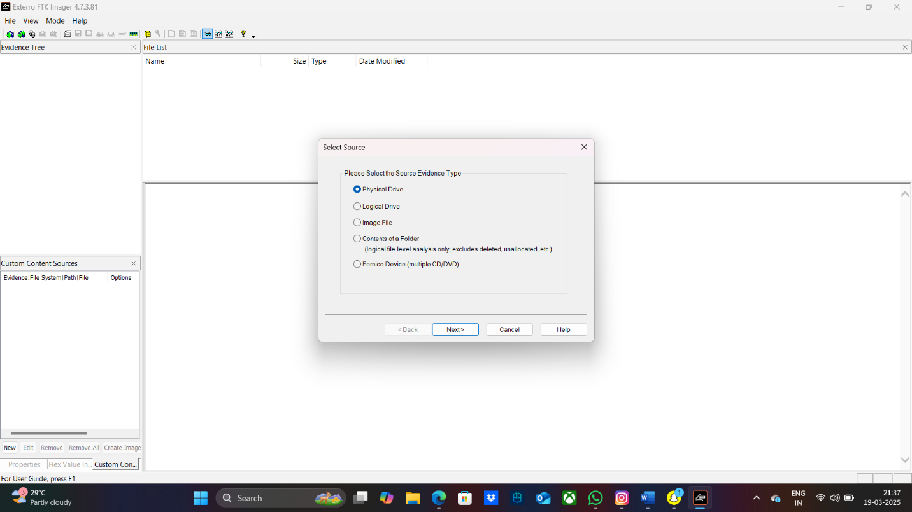

**Step 1**

**Step 2**

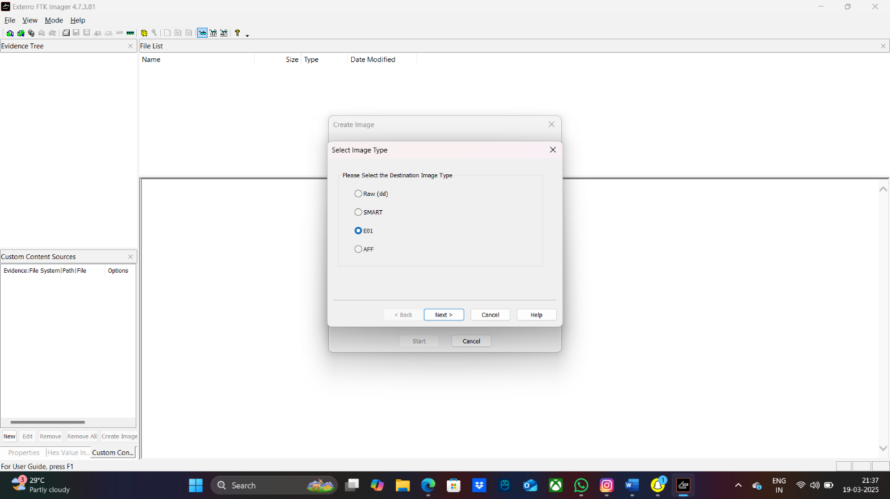

**Step 3**

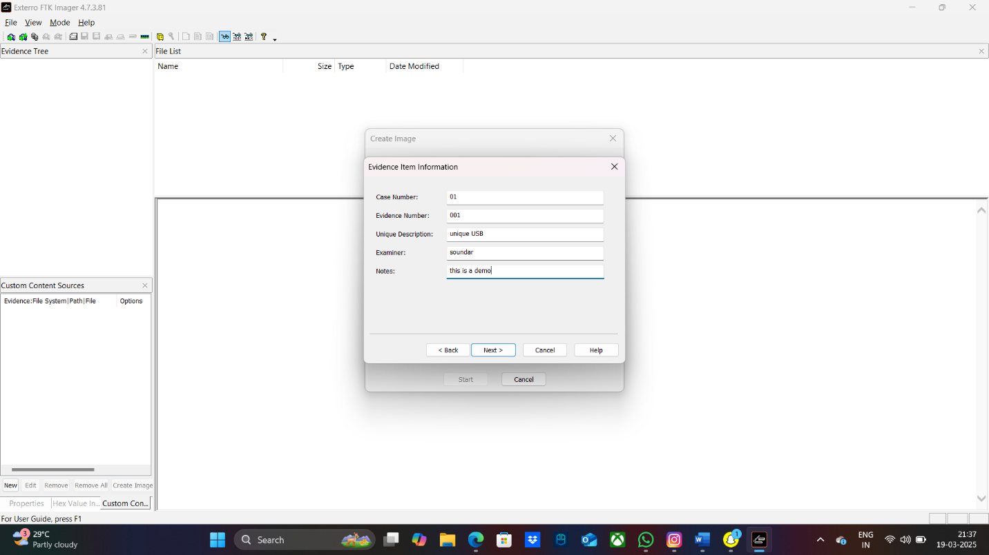

**Step 4**

**Step 5**

**Step 6**

**Step 7**

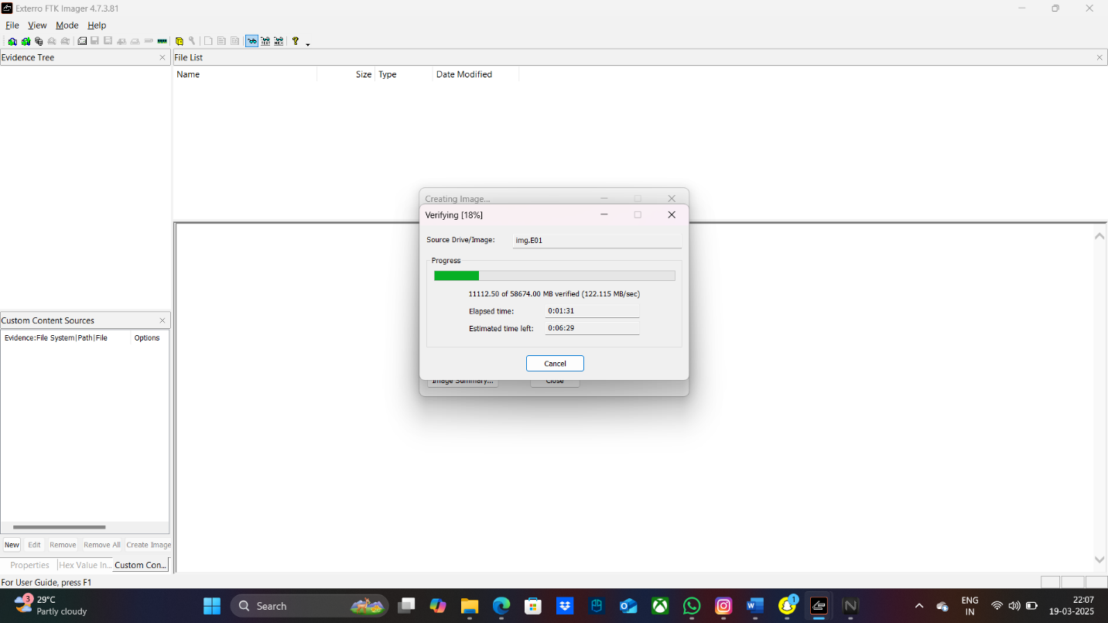

**Step 8**

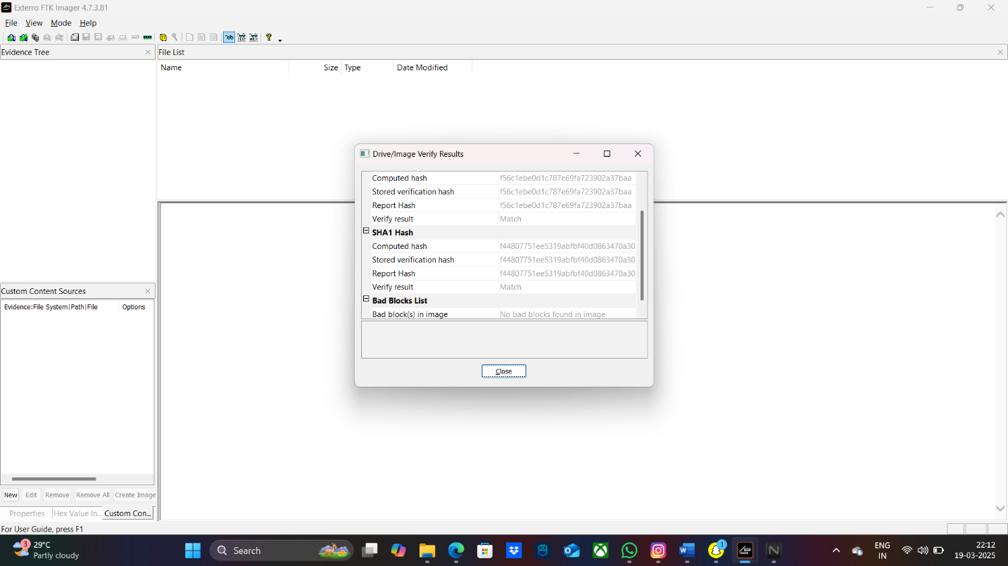

**Step 9**

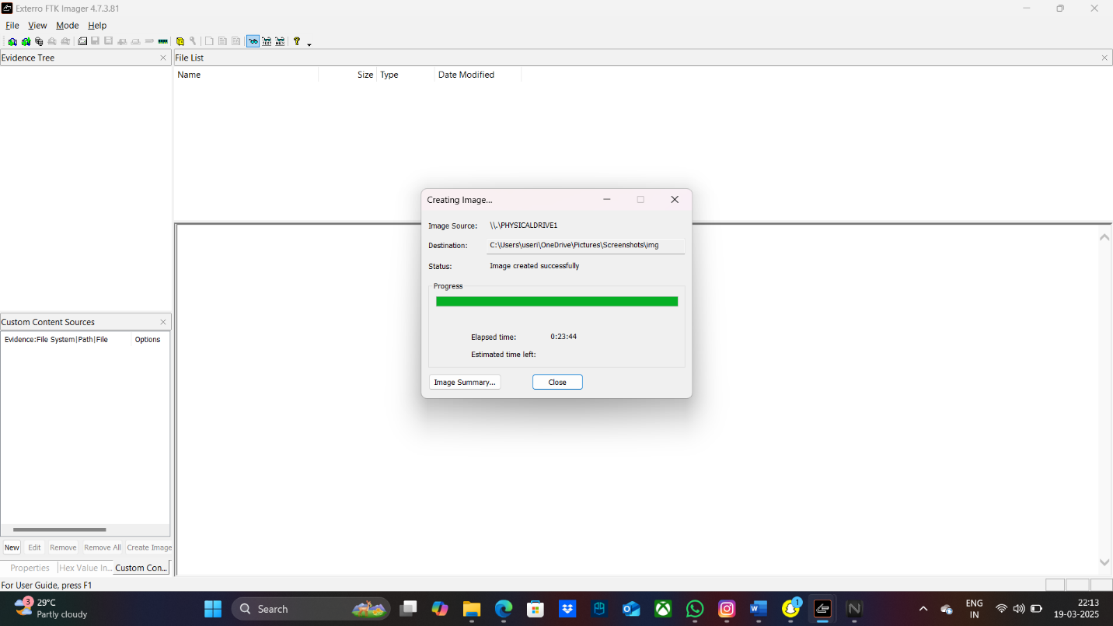

**Step 10**

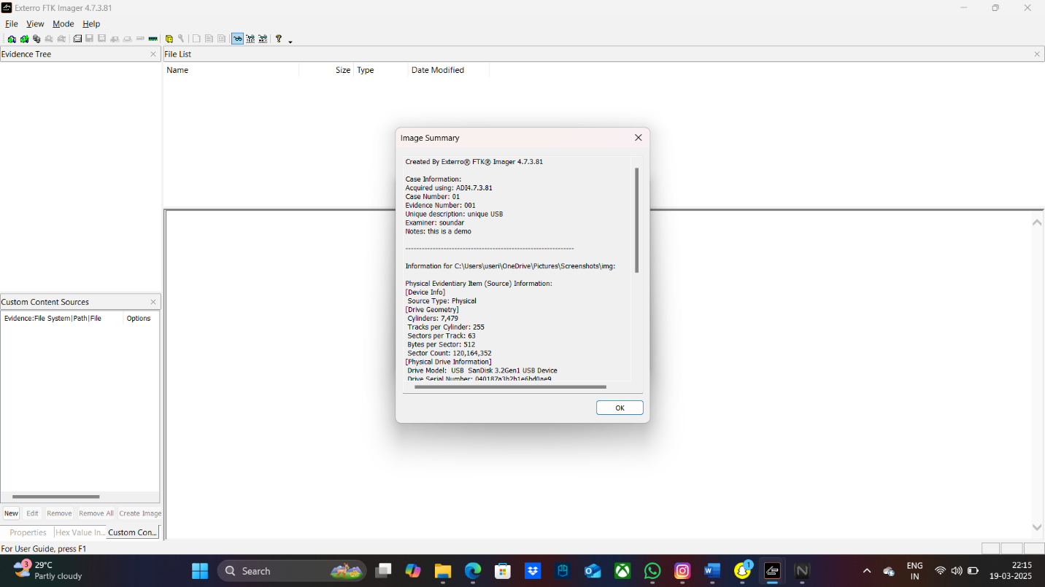

**Step 11**

**Step 12**